**PROJECT REPORT**

REAL-TIME COMMUNICATION SYSTEM POWERED BY AI SPECIALLY ABLED

***submitted by***

***PNT2022TMID40612***

|  |  |  |
| --- | --- | --- |
| BHUVANESH.K | - | 610919104017 |
| ARTHI.A | - | 610919104010 |
| KOKILA.M | - | 610919104042 |
| JAYASUDHA.K | - | 610919104033 |

**TABLE OF CONTENTS**

|  |  |  |
| --- | --- | --- |
| **1** | **INTRODUCTION** | **1** |
|  | 1.1 PROJECT OVERVIEW | 1 |
|  | 1.2 PURPOSE | 1 |
|  | **2 LITERATURE SURVEY** | **2** |
|  | 2.1 EXISTING PROBLEM | 2 |
|  | 2.2 REFERENCES | 2 |
|  | 2.3 PROBLEM STATEMENT DEFINITION | 5 |
|  | **3 IDEATION AND PROPOSED SOLUTION** | **6** |
|  | 3.1 EMPATHY MAP CANVAS | 6 |
|  | 3.2 IDEATION & BRAINSTORMING | 7 |
|  | 3.3 PROPOSED SOLUTION | 8 |
|  | 3.4 PROBLEM SOLUTION FIT | 9 |
|  | **4 REQUIREMENT ANALYSIS** | **10** |
|  | 4.1 FUNCTIONAL REQUIREMENTS | 10 |
|  | 4.2 NON FUNCTIONAL REQUIREMENTS | 11 |
|  | **5 PROJECT DESIGN** | **12** |
|  | 5.1 DATA FLOW DIAGRAM | 12 |
|  | 5.2 SOLUTION & TECHNICAL ARCHITECTURE | 13 |
|  | 5.3 USER STORIES | 15 |

1. PROJECT PLANNING AND SCHEDULING 16

SPRINT PLANNING AND ESTIMATION 16

SPRINT DELIVERY SCHEDULE 17

1. CODING & SOLUTIONING 18
2. TESTING 20

TEST CASES 20

USER ACCEPTANCE TESTING 22

DEFECT ANALYSIS 22

TEST CASE ANALYSIS 22

1. RESULTS 23

PERFORMANCE METRICS 23

1. ADVANTAGES & DISADVANTAGES 25

ADVANTAGES 25

DISADVANTAGES 25

1. CONCLUSION 26
2. FUTURE SCOPE 27

APPENDIX 28

SOURCE CODE 28

GITHUB 37

PROJECT DEMO 37

# CHAPTER 1

## INTRODUCTION

### PROJECT OVERVIEW

Artificial Intelligence is not designed to replace humans but rather to enhance our lives by helping us do things we are unable to do on our own.Many companies are working on this type of research ,including Google deepmind,IBM Watson,Apple sri,Microsoft Cortana, ect.,Which means there will likely be many new developments soon.These innovations could positively impacteveryone’s life – even those without disabilities – because the make everyday tasks easier and less time-consuing.

### 

### PURPOSE

A making use of a convolution neural to create a model that is trained on different hand gestures.An app is built which uses this model.This app enables deaf and dumb people to convey their information using signs which get converted to human-understandable language and speech is gives as output. Facial recognition technology is quickly becoming a part of everyday life. It’s used to improve public security, the accuracy of photo tagging and even make grocery shopping easier. But those who can’t speak or move? Facial recognition has the potential to offer independence and inclusion for these individuals. This means that people with disabilities can get a job or go out without needing a caregiver or companion to help them find their way around and do things independently. From entertainment to security, many aspects of daily life have been improved through this advancement in technology. These technologies reached their peak when smartphones became more available to the public market. Today, facial recognition software is being used for blind children to read books aloud and as an accessible way for deaf people to communicate with others via video chat.

# CHAPTER 2

## LITERATURE SURVEY

### EXISTING PROBLEM

The fundamental problem with handwritten digit recognition is that handwritten digits do not always have the same size, width, orientation, and margins since they vary from person to person. Additionally, there would be issues with identifying the numbers because of similarities between numerals like 1 and 7, 5 and 6, 3 and 8, 2 and 5, 2 and 7, etc. Finally, the individuality and variation of each individual's handwriting inﬂuence the structure and appearance of the digits.

### REFERENCES

#### Improved Handwritten Digit Recognition Using Convolutional Neural Networks (CNN) (2020)

*Ahlawat, Savita and Choudhary, Amit and Nayyar, Anand and Singh, Saurabh and Yoon, Byungun*

This paper's primary goal was to enhance handwritten digit recognition ability. To avoid difﬁcult pre-processing, expensive feature extraction, and a complex ensemble (classiﬁer combination) method of a standard recognition system, they examined different convolutional neural network variations. Their current work makes suggestions on the function of several hyper-parameters through thorough evaluation utilizing an MNIST dataset. They also conﬁrmed that optimizing

hyper-parameters is crucial for enhancing CNN architecture performance. With the Adam optimizer for the MNIST database, they were able to surpass many previously published results with a recognition rate of 99.89%. Through the trials, it is made abundantly evident how the performance of handwritten digit recognition is affected by the number of convolutional layers in CNN architecture. According to the paper, evolutionary algorithms can be explored for optimizing convolutional ﬁlter kernel sizes, CNN learning parameters, and the quantity of layers and learning rates.

#### An Efﬁcient And Improved Scheme For Handwritten Digit Recognition Based On Convolutional Neural Network (2019)

*Ali, Saqib and Shaukat, Zeeshan and Azeem, Muhammad and Sakhawat, Zareen and Mahmood, Tariq and others*

This study uses rectiﬁed linear units (ReLU) activation and a convolutional neural network (CNN) that incorporates the Deeplearning4j (DL4J) architecture to recognize handwritten digits. The proposed CNN framework has all the necessary parameters for a high level of MNIST digit classiﬁcation accuracy. The system's training takes into account the time factor as well. The system is also tested by altering the number of CNN layers for additional accuracy veriﬁcation. It is important to note that the CNN architecture consists of two convolutional layers, the ﬁrst with 32 ﬁlters and a 5x5 window size and the second with 64 ﬁlters and a 7x7 window size. In comparison to earlier proposed systems, the experimental ﬁndings show that the proposed CNN architecture for the MNIST dataset demonstrates great performance in terms of time and accuracy. As a result, handwritten numbers are detected with a recognition rate of 99.89% and high precision (99.21%) in a short amount of time.

#### Handwritten Digit Recognition Using Machine And Deep Learning Algorithms (2021)

*Pashine, Samay and Dixit, Ritik and Kushwah, Rishika*

In this study, they developed three deep and machine learning-based models for handwritten digit recognition using MNIST datasets. To determine which model was the most accurate, they compared them based on their individual properties.

Support vector machines are among the simplest classiﬁers, making them faster than other algorithms and providing the highest training accuracy rate in this situation. However, due to their simplicity, SVMs cannot categorize complicated and ambiguous images as accurately as MLP and CNN algorithms can. In their research, they discovered that CNN produced the most precise outcomes for handwritten digit recognition. This led them to the conclusion that CNN is the most effective solution for all types of prediction issues, including those using picture data. Next, by comparing the execution times of the algorithms, they determined that increasing the number of epochs without changing the conﬁguration of the algorithm is pointless due to the limitation of a certain model, and they discovered that beyond a certain number of epochs, the model begins over-ﬁtting the dataset and provides biased predictions.

### PROBLEM STATEMENT DEFINITION

Artificial Intelligence has been opening up new and simpler ways to manage our daily activities. With the big potential to automate tasks that typically require human intelligence, such as speech and voice recognition, visual perception, predictive text functionality, decision-making and performance of a variety of other tasks, AI can help individuals with disabilities by making a major difference in their ability to get around and take part in the activities of daily living.

The Problem for AI Using driverless cars enables disabled people to leave the house, get around their communities, interact with people, and even find jobs. Once autonomous vehicles are fully integrated into society, they could ease independent mobility, and increased accessibility adapted to each user's abilities and needs. Artificial Intelligence has been opening up new and simpler ways to manage our daily activities. With the big potential to automate tasks that typically require human intelligence, such as speech and voice recognition, visual perception, predictive text functionality, decision-making and performance of a variety of other tasks, AI can help individuals with disabilities by making a major difference in their ability to get around and take part in the activities of daily living.

# CHAPTER 3

## IDEATION AND PROPOSED SOLUTION

### EMPATHY MAP CANVAS

**IDEATION & BRAINSTORMING**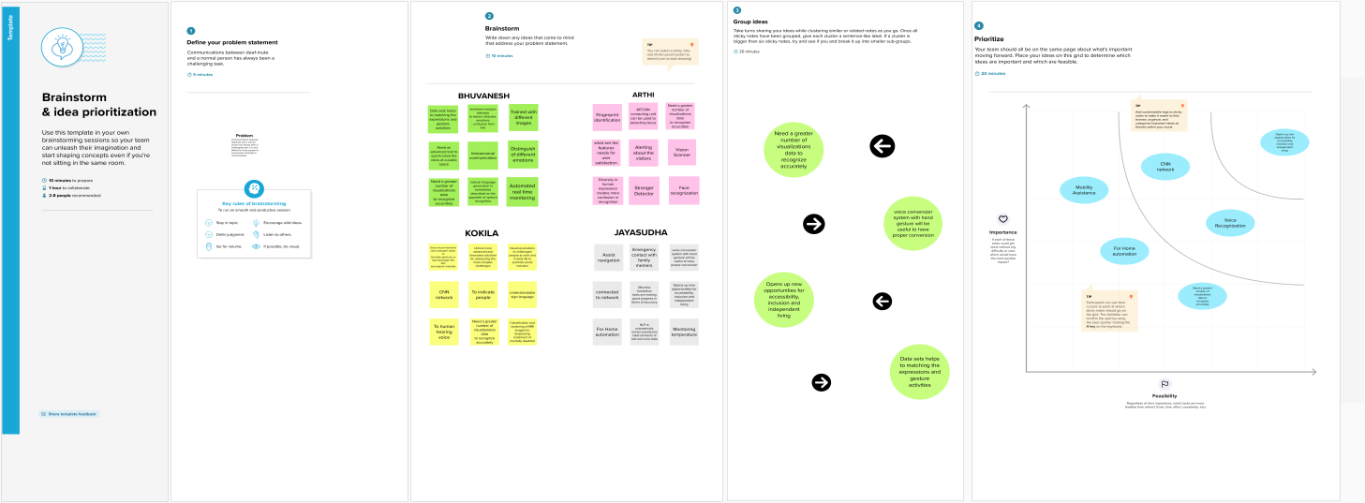

### PROPOSED SOLUTION

|  |  |  |
| --- | --- | --- |
| **S.NO** | **PARAMETER** | **DESCRIPTION** |
| 1 | Problem Statement | The main objectives is to build a communiation system which enables communication between a speech hearing impaired and a normal person |
| 2 | Idea / Solution Description | The proposed solution uses a Deep Neural Network architecture that recognizes a sign language symbol.The image of the symbol or sign mode by a person is captured via a webcam,which is then fed into the model. |
| 3 | Novelty / Uniqueness | The proposed model is more efficient and can also be accessible by lots of people since it will be deployed on the internet with a user-friendly interface |
| 4 | Social Impact / Customer Satisfaction | This model introduced the gateway for deaf, and the blind. It’s difficult to educate the public about the language of disabled people and this model will actually make communication easier and bridge the gap between people |
| 5 | Business Model | This model will be made easily accessible to the general public and satisfies their exiting needs and also provides for their new needs. The cost will be user friendly, with different updates,cost may vary |
| 6 | Scalability of the Solution | With adequate funding and manpower,the proposed model can be scaled up,which would make it a more sophisticate system that can recognize multipile sign languages and also convert into multiple normal languages |

**PROBLEM SOLUTION FIT**

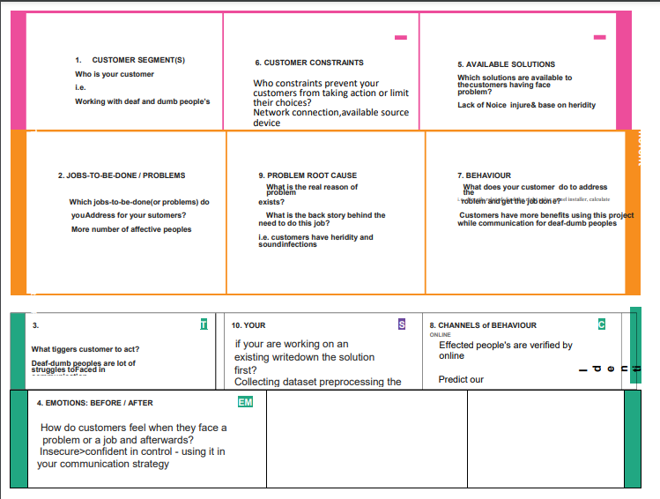

# CHAPTER 4

## REQUIREMENT ANALYSIS

### FUNCTIONAL REQUIREMENTS:

|  |  |  |
| --- | --- | --- |
| **FR.NO** | **FUNCTIONAL REQUIREMENTS** | **SUB REQUIREMENTS** |
| FR-1 | Model Creation | Get access the MNIST dataset |
| Analyze the dataset |
| Deﬁne a CNN model |
| Train and Test the Model |
| FR-2 | Application Development | Create a website to let the user recognize handwritten digits. |
| Create a home page to upload images |
| Create a result page to display the results |
| Host the website to let the users use it from anywhere |
| FR-3 | Input Image Upload | Let users upload images of various formats. |
| Let users upload images of various size |
| Prevent users from uploading unsupported image formats |
| Pre-Process the image to use it on the model |

|  |  |  |
| --- | --- | --- |
|  |  | Create a database to store all the input images |
| FR-4 | Display Results | Display the result from the model |
| Display input image |
| Display accuracy the result |
| Display other possible predictions with their respective accuracy |

**NON FUNCTIONAL REQUIREMENTS**

|  |  |  |
| --- | --- | --- |
| **NFR** | **NON-FUNCTIONAL REQUIREMENTS** | **DESCRIPTION** |
| NFR-1 | Usability | The application must be usable in all devices |
| NFR-2 | Security | The application must protect user uploaded image |
| NFR-3 | Reliability | The application must give an accurate result as much as possible |
| NFR-4 | Performance | The application must be fast and quick to load up |
| NFR-5 | Availability | The application must be available to use all the time |
| NFR-6 | Scalability | The application must scale along with the user base |

# CHAPTER 5

## PROJECT DESIGN

### DATA FLOW DIAGRAM

### 

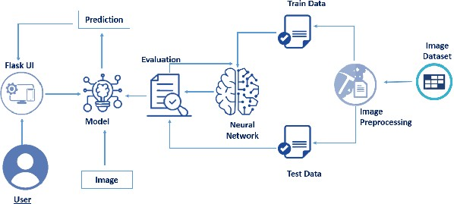**SOLUTION & TECHNICAL ARCHITECTURE**

**USER STORIES**

|  |  |  |  |  |  |  |
| --- | --- | --- | --- | --- | --- | --- |
| User Type | Functional Requirement (Epic) | User Story Number | User Story/ Task | Acceptanc e criteria | Priority | Release |
| Normal people and Deaf-mute people | Registration | USN-1 | As a user, I can register for the application by entering my email, and password, and confirming my password | I can access my account/d ashboard | High | Sprint-1 |
|  |  | USN-2 | As a user, I will receive a confirmation email once I have registered for the application | I can receive a confirmati on email & click  confirm | High | Sprint-1 |
| Normal people |  | USN-3 | Give access tocamera to recognize the gestures Give access tomicrophone to give our message through voice | I can access messages given by the Deaf- mute  people | High | Sprint-1 |
| Deaf-mute people |  |  | Give access to display to view the message sent by normal people. | I can access messages given by the Normal  people | High | Sprint-1 |
| Administrator |  | USN-4 | Admin side in the company should take care. | all the requireme nts are there | High | Sprint-1 |
| Sign up |  | USN-5 | Need to sign up to use it. | Need valid credentials | High | Sprint-1 |
| Wish list |  | USN-6 | Before availing the service can be kept aside. | As a user can review and use the  service. | Low | Sprint-2 |

# CHAPTER 6

## PROJECT PLANNING AND SCHEDULING

|  |  |  |  |  |  |  |
| --- | --- | --- | --- | --- | --- | --- |
| **Sprint** | **Functional Requirement (Epic)** | **User Story Number** | **User Story / Task** | **Story Points** | **Priority** | **Team Members** |
| Sprint-1 | Registration | USN-1 | As a user, I can register for the application by entering my email, password, and confirming my password. | 2 | High | BHUVANESH K |
| Sprint-2 | Action | USN-2 | As a user, I will receive confirmation email once I have registered for the application | 1 | High | KOKILA M |
| Sprint-1 | Login | USN-3 | As a user, I can log into the application by entering email & password | 1 | Medium | BHUVANESH K |
| Sprint-2 | Dashboard | USN-4 | As a user, I can log into my account in a given Dashboard | 1 | High | KOKILA M |
| Sprint-1 | User interface | USN-5 | Professional responsible for user requirements & needs | 1 | High | BHUVANESH K |
| Sprint-3 | Objective | USN-6 | The goal is to describe all the inputs and outputs | 1 | High | KOKILA M |
| Sprint-4 | Privacy | USN-7 | The developed application should be secure for the users | 1 | High | JAYASUDHA K |

### SPRINT DELIVERY SCHEDULE

|  |  |  |  |  |  |  |
| --- | --- | --- | --- | --- | --- | --- |
| **Sprint** | **Total Story Points** | **Duration** | **Sprint Start Date** | **Sprint End Date (Planned)** | **Story Points Completed (as on Planned End Date)** | **Sprint Release Date (Actual)** |
| Sprint-1 | 20 | 6 Days | 6 Nov 2022 | 16 Nov 2022 | 20 | 16 Nov 2022 |
| Sprint-2 | 20 | 6 Days | 11 Nov 2022 | 17 Nov 2022 | 20 | 17 Nov 2022 |
| Sprint-3 | 20 | 6 Days | 13 Nov 2022 | 19 Nov 2022 | 20 | 19 Nov 2022 |
| Sprint-4 | 20 | 6 Days | 15 Nov 2022 | 20 Nov 2022 | 20 | 20 Nov 2022 |

# CHAPTER 7

**CODING & SOLUTIONING**

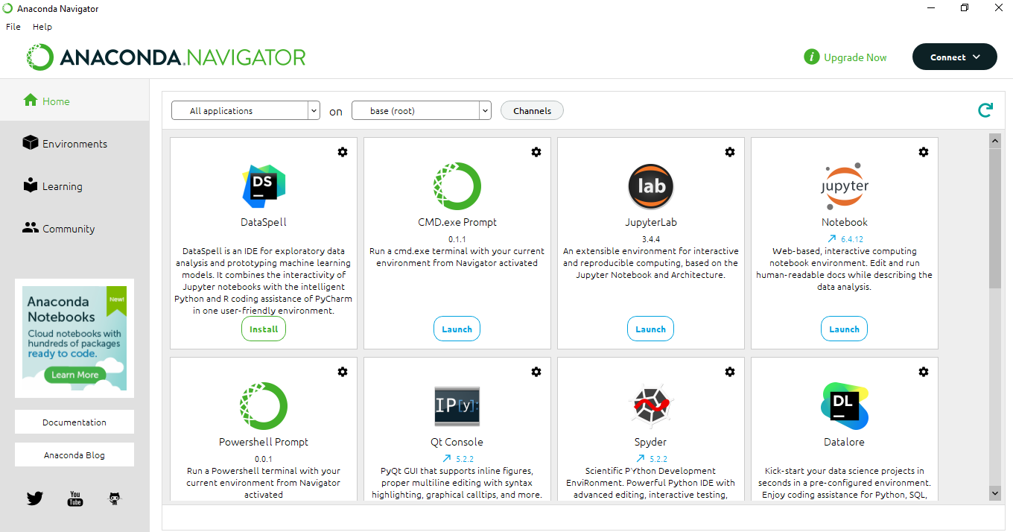

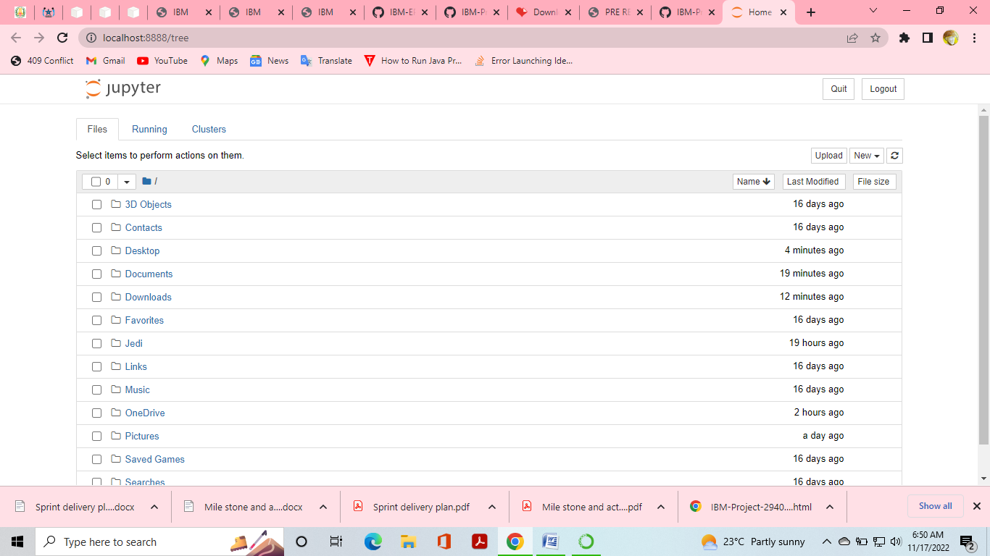

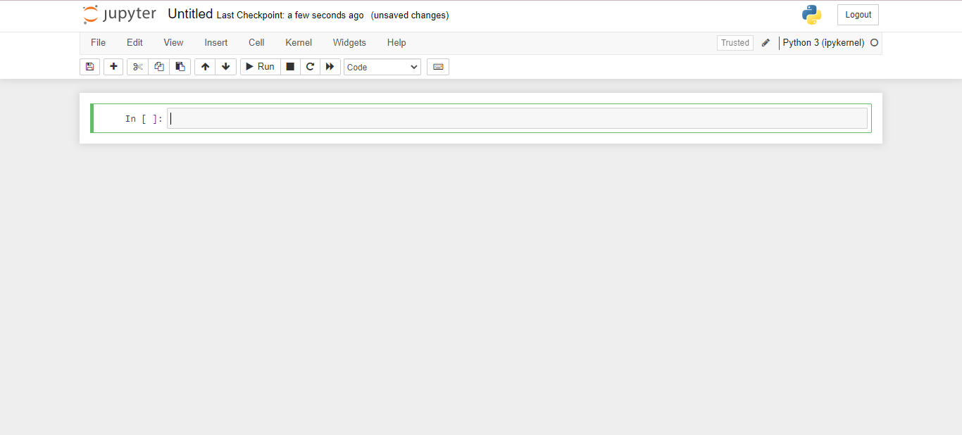

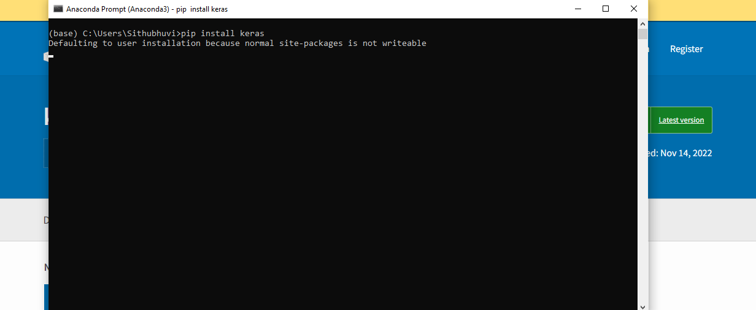

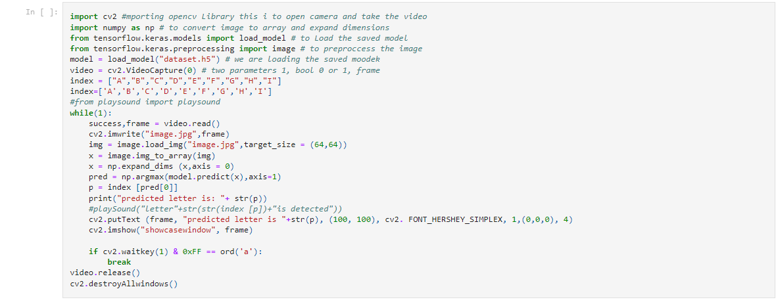

# CHAPTER 8

## TESTING

### TEST CASES

|  |  |  |  |  |  |  |
| --- | --- | --- | --- | --- | --- | --- |
| **Test case ID** | **Feature Type** | **Component** | **Test Scenario** | **Expected Result** | **Actual Result** | **Status** |
| HP_TC_001 | UI | Home Page | Verify UI elements in the Home Page | The Home page must be displayed properly | Working as expected | PASS |
| HP_TC_002 | UI | Home Page | Check if the UI elements are displayed properly in different screen sizes | The Home page must be displayed properly in all sizes | The UI is not displayed properly in screen size 2560 x 1801  and 768 x 630 | FAIL |
| HP_TC_003 | Functional | Home Page | Check if user can upload their ﬁle | The input image should be uploaded to the application successfully | Working as expected | PASS |
| HP_TC_004 | Functional | Home Page | Check if user cannot upload unsupported ﬁles | The application should not allow user to select a non image ﬁle | User is able to upload any ﬁle | FAIL |
| HP_TC_005 | Functional | Home Page | Check if the page redirects to the result page once the input is given | The page should redirect to the results page | Working as expected | PASS |

|  |  |  |  |  |  |  |
| --- | --- | --- | --- | --- | --- | --- |
| BE_TC_001 | Functional | Backend | Check if all the routes are working properly | All the routes should properly work | Working as expected | PASS |
| M_TC_001 | Functional | Model | Check if the model can handle various image sizes | The model should rescale the image and predict the results | Working as expected | PASS |
| M_TC_002 | Functional | Model | Check if the model predicts the digit | The model should predict the number | Working as expected | PASS |
| M_TC_003 | Functional | Model | Check if the model can handle complex input image | The model should predict the number in the complex image | The model fails to identify the digit since the model is not  built to handle such data | FAIL |
| RP_TC_001 | UI | Result Page | Verify UI elements in the Result Page | The Result page must be displayed properly | Working as expected | PASS |
| RP_TC_002 | UI | Result Page | Check if the input image is displayed properly | The input image should be displayed properly | The size of the input image exceeds the display  container | FAIL |
| RP_TC_003 | UI | Result Page | Check if the result is displayed properly | The result should be displayed properly | Working as expected | PASS |
| RP_TC_004 | UI | Result Page | Check if the other predictions are displayed properly | The other predictions should be displayed properly | Working as expected | PASS |

**USER ACCEPTANCE TESTING****DEFECT ANALYSIS**

|  |  |  |  |  |  |
| --- | --- | --- | --- | --- | --- |
| Resolution | Severity 1 | Severity 2 | Severity 3 | Severity 4 | Total |
| By Design | 1 | 0 | 1 | 0 | 2 |
| Duplicate | 0 | 0 | 0 | 0 | 0 |
| External | 0 | 0 | 2 | 0 | 2 |
| Fixed | 4 | 1 | 0 | 1 | 6 |
| Not Reproduced | 0 | 0 | 0 | 1 | 1 |
| Skipped | 0 | 0 | 0 | 1 | 1 |
| Won’t Fix | 1 | 0 | 1 | 0 | 2 |
| Total | 6 | 1 | 4 | 3 | 14 |

### TEST CASE ANALYSIS

|  |  |  |  |  |
| --- | --- | --- | --- | --- |
| Section | Total Cases | Not Tested | Fail | Pass |
| Client Application | 10 | 0 | 3 | 7 |
| Security | 2 | 0 | 1 | 1 |
| Performance | 3 | 0 | 1 | 2 |
| Exception Reporting | 2 | 0 | 0 | 2 |

# CHAPTER 9

## RESULTS

### PERFORMANCE METRICS

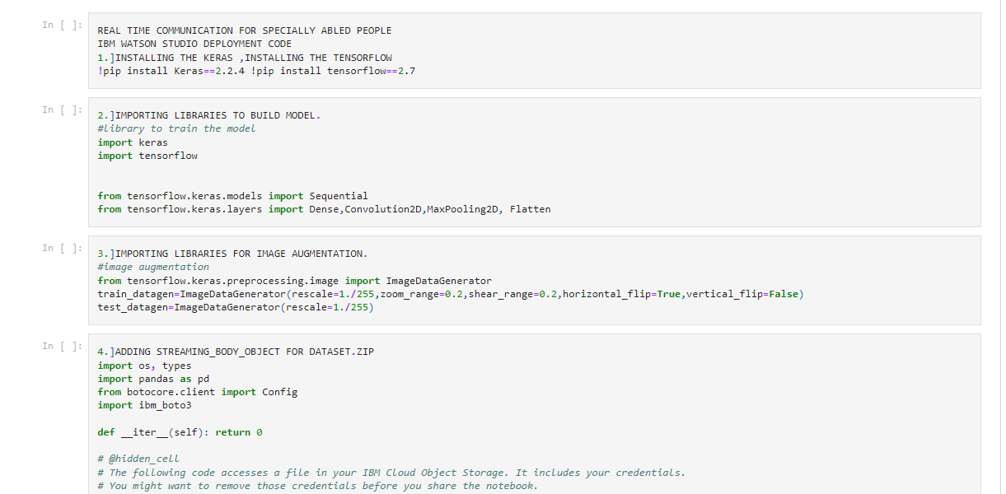

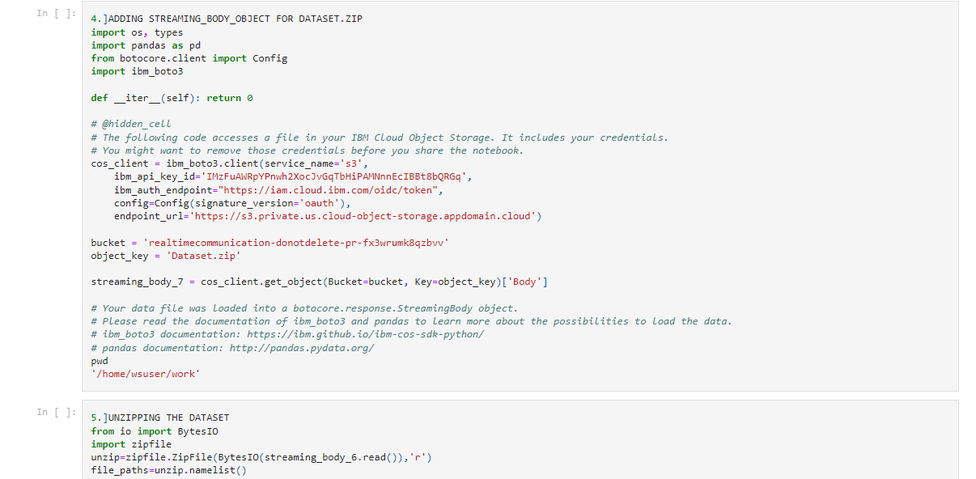

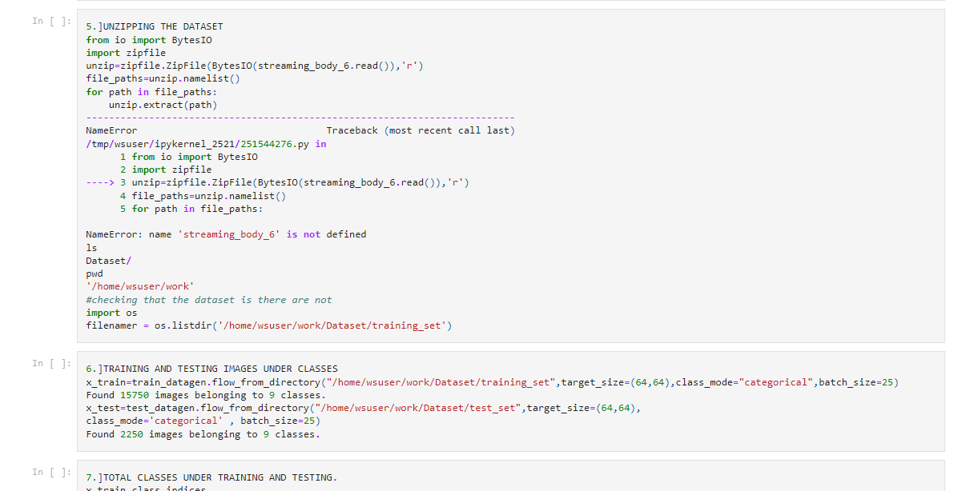

# CHAPTER 10

## ADVANTAGES & DISADVANTAGES

### ADVANTAGES

* Reduces manual work
* More accurate than average human
* Capable of handling a lot of data
* Can be used anywhere from any device

### DISADVANTAGES

* Cannot handle complex data
* All the data must be in digital format
* Requires a high performance server for faster predictions
* Prone to occasional errors

**CHAPTER 11**

## CONCLUSION

This project demonstrated a web application that uses machine learning And NuralNetwork to recognise handwritten numbers. Flask, HTML, CSS, JavaScript, and a few other technologies were used to create this project. The model predicts the handwritten digit using a CNN network. During testing, the model achieved a 99.61% recognition rate. The proposed project is scalable and can easily handle a huge number of users. Since it is a web application, it is compatible with any device that can run a browser. This project is extremely useful in real-world scenarios such as recognizing number plates of vehicles, processing bank cheque amounts, numeric entries in forms ﬁlled up by hand (tax forms) and so on. There is so much room for improvement, which can be implemented in subsequent versions.

# CHAPTER 12

## FUTURE SCOPE

This project is far from complete and there is a lot of room for improvement.

Some of the improvements that can be made to this project are as follows:

* Add support to detect from digits multiple images and save the results
* Add support to detect multiple digits
* Add support to multi reactions fuction
* Improve model to detect digits from complex images
* Add support to different languages to help users from all over the world

This project has endless potential and can always be enhanced to become better. Implementing this concept in the real world will beneﬁt several industries and reduce the workload on many workers, enhancing overall work efﬁciency.

## APPENDIX

### SOURCE CODE

MODEL CREATION



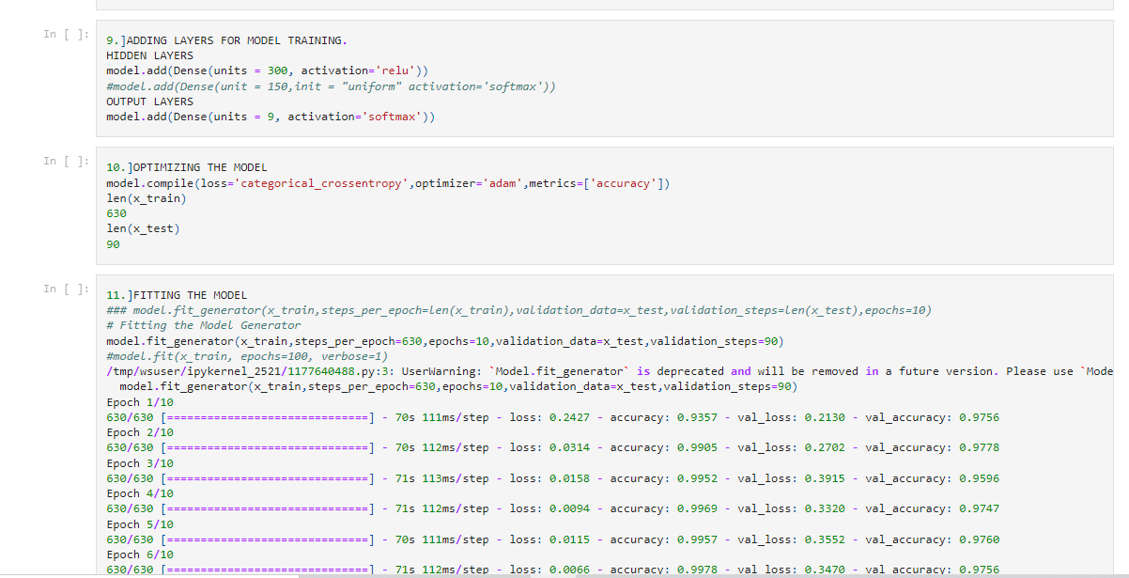







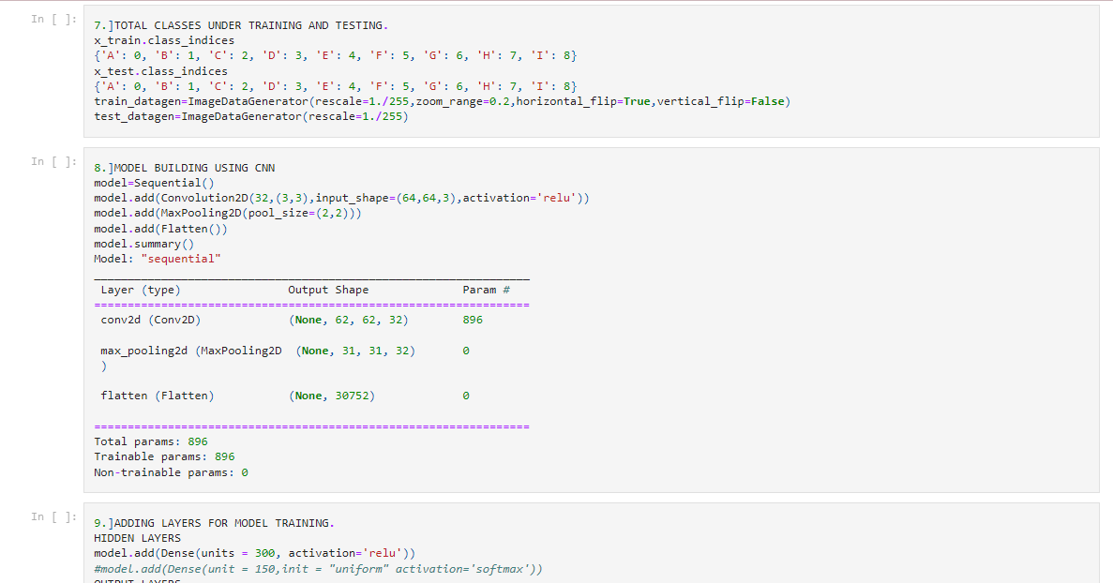



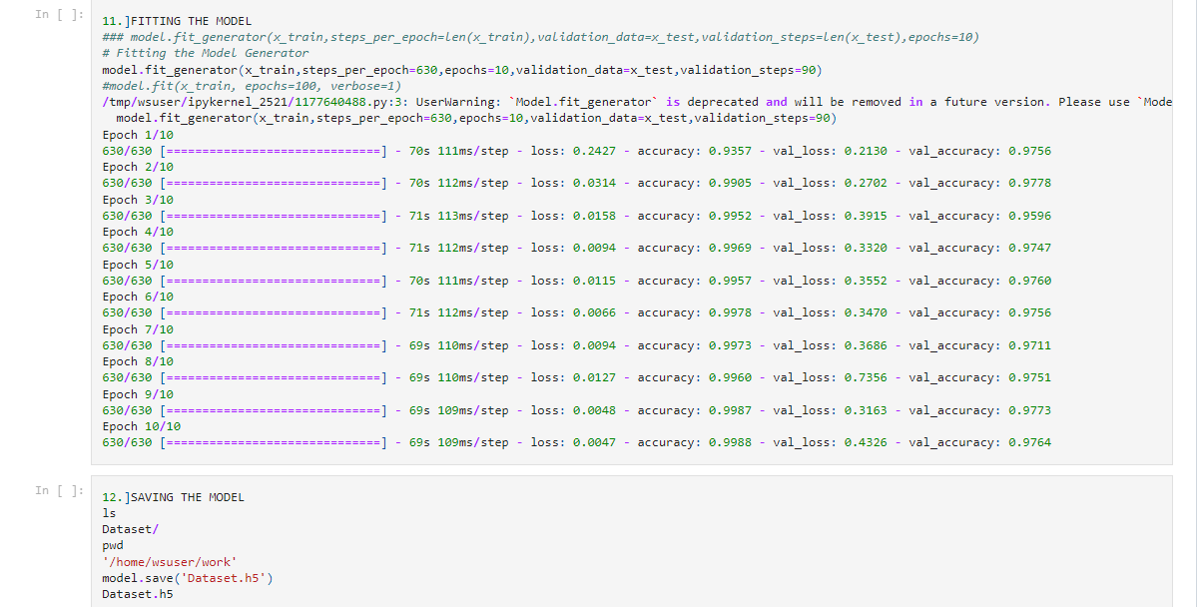

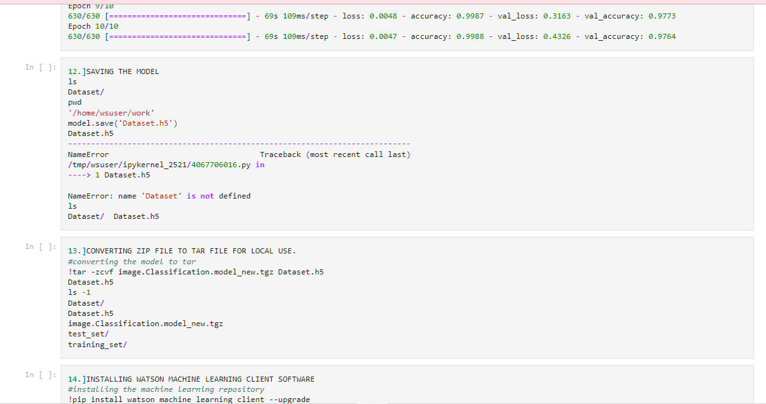

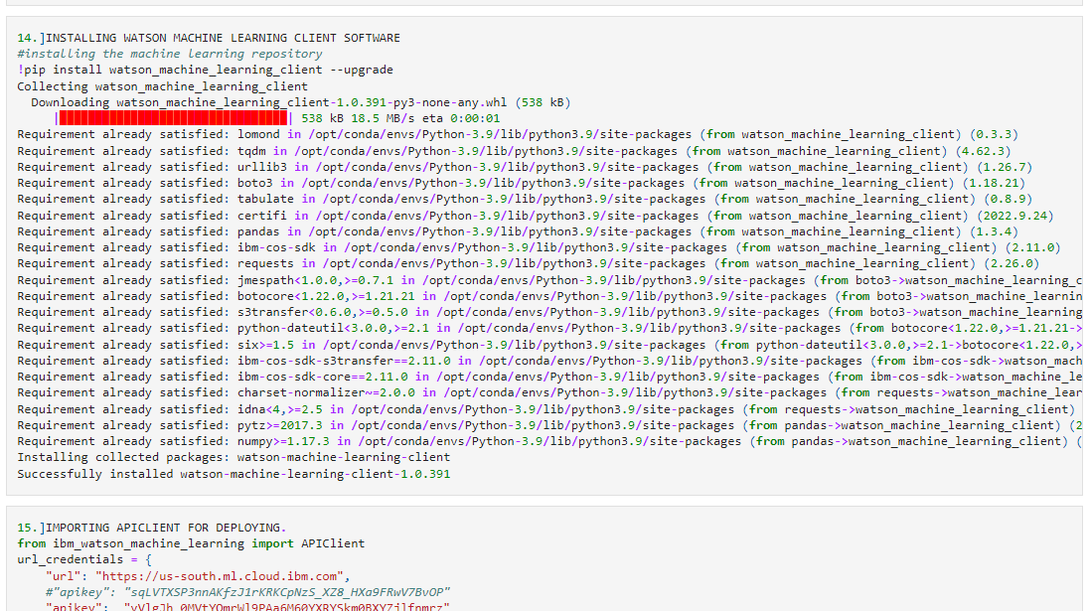

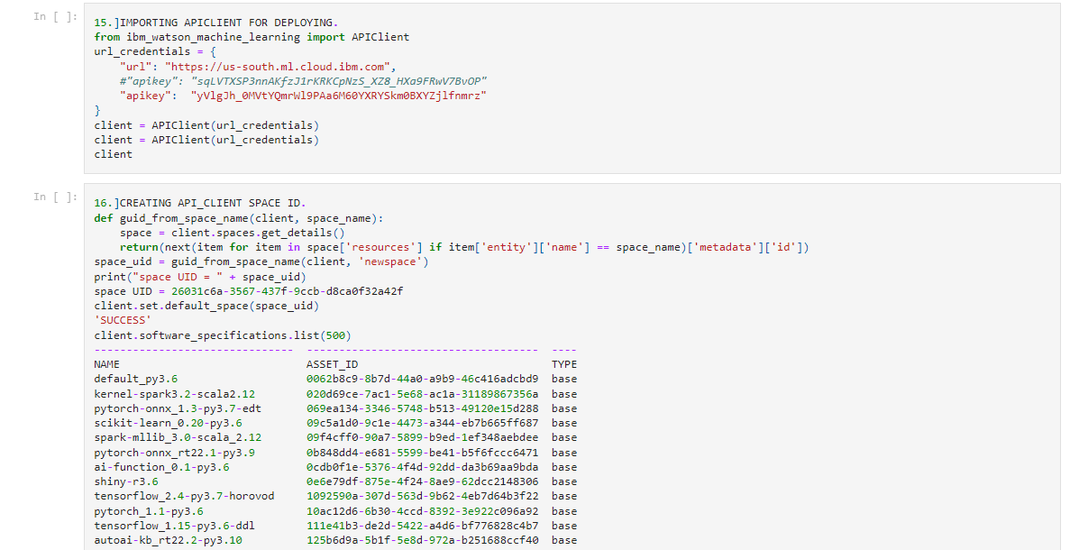

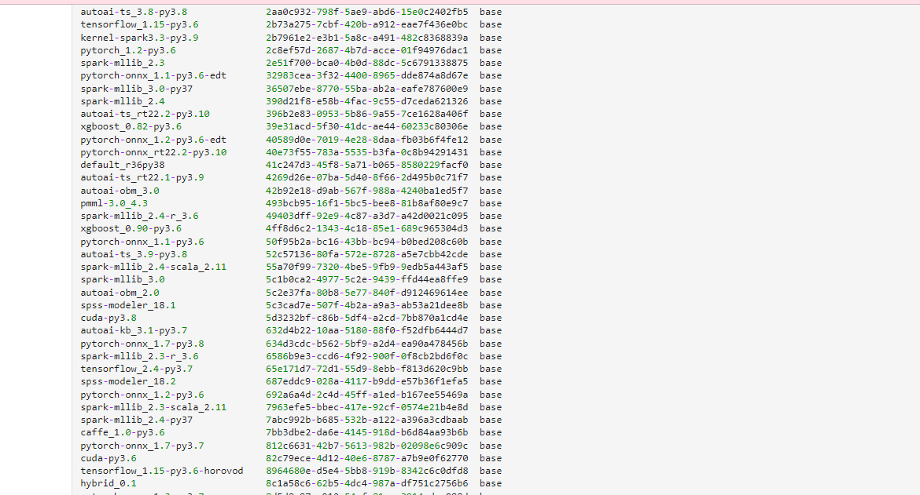



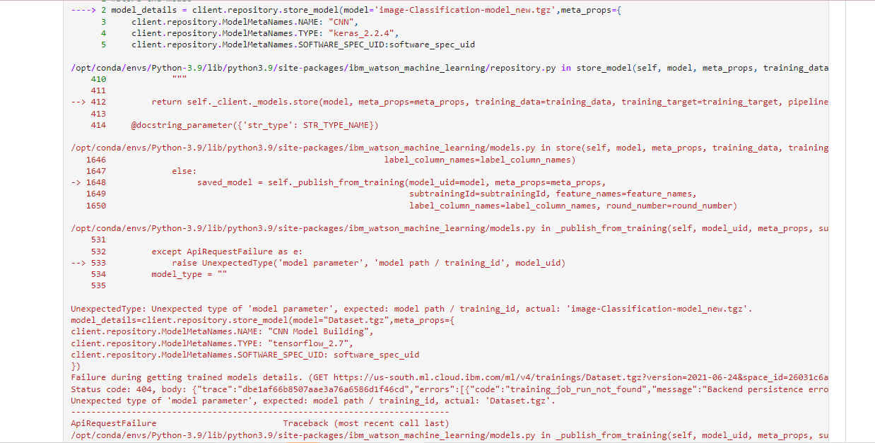

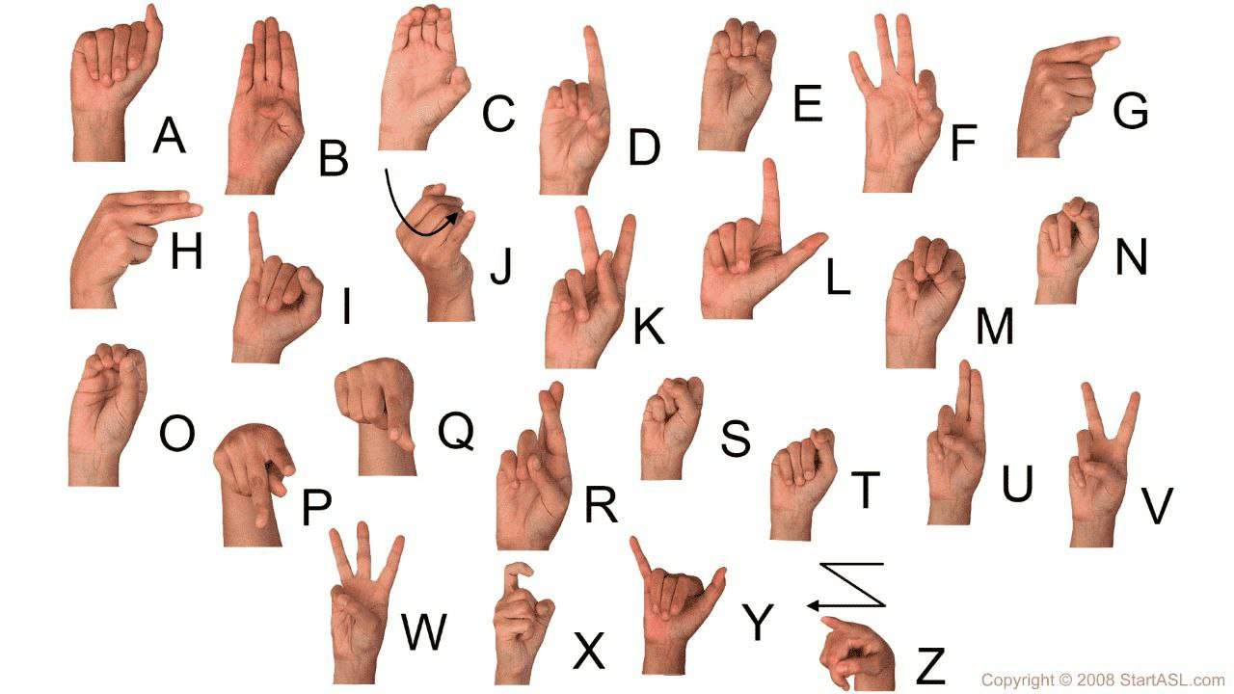

### GITHUB

https://github.com/IBM-EPBL/IBM-Project-52118-1660989503